Wake up: six reasons to choose Fairtrade coffee

Many of us start the day with a cup of coffee (ok, maybe more than one…).

But with our morning lattes relying on the hard work of more than 25 million smallholder farmers around the world, we should also spare a thought for what goes into growing those delicious beans.

Here are six important reasons to choose Fairtrade on International Coffee Day – and every day!

It tastes great.
Think you have to sacrifice quality for fairness? Think again! At a competition last year in Kenya, four out of the top 10 coffees were Fairtrade certified. More than half of Fairtrade coffee sold is also certified organic. Fairtrade’s regional producer networks are training farmers how to continue improving their quality, and also how to market it successfully.

The Fairtrade Minimum Price is a safety net for farmers facing plunging coffee prices.
The global market price for arabica coffee fell to a 12-year low last year, to below US$1 per pound. That’s well below the cost of production for many farmers, and means families are struggling to survive. One study found that two thirds of coffee farmers in Nicaragua, Guatemala and Mexico experience three to eight ‘thin months’ of extreme food scarcity from when their earnings run out to the beginning of the next harvest season. Unable to make a living, coffee farmers are making the difficult choice to migrate to cities or abroad.

The Fairtrade Minimum Price guarantees that farmer cooperatives earn at least $1.40 per pound (or $1.70 for organic), plus the additional Fairtrade Premium of 20 cents per pound that they decide for themselves how to invest. Together that’s 65 percent more than the average market price of $0.97 cents per pound over the first six months of this year.

This isn’t the first time prices have plunged. Coffee prices are highly volatile, making it impossible for farmers to plan. Fairtrade’s Minimum Price is a source of security, protecting farmers when market prices dip too low, and allowing them to earn more when the market price is higher. In fact, the chart below shows that the Fairtrade Minimum Price has been in effect for approximately 20 out of the past 30 years. That’s two decades of a crucial safety net, which is now more important than ever with higher farming costs and other economic, social and environmental challenges.

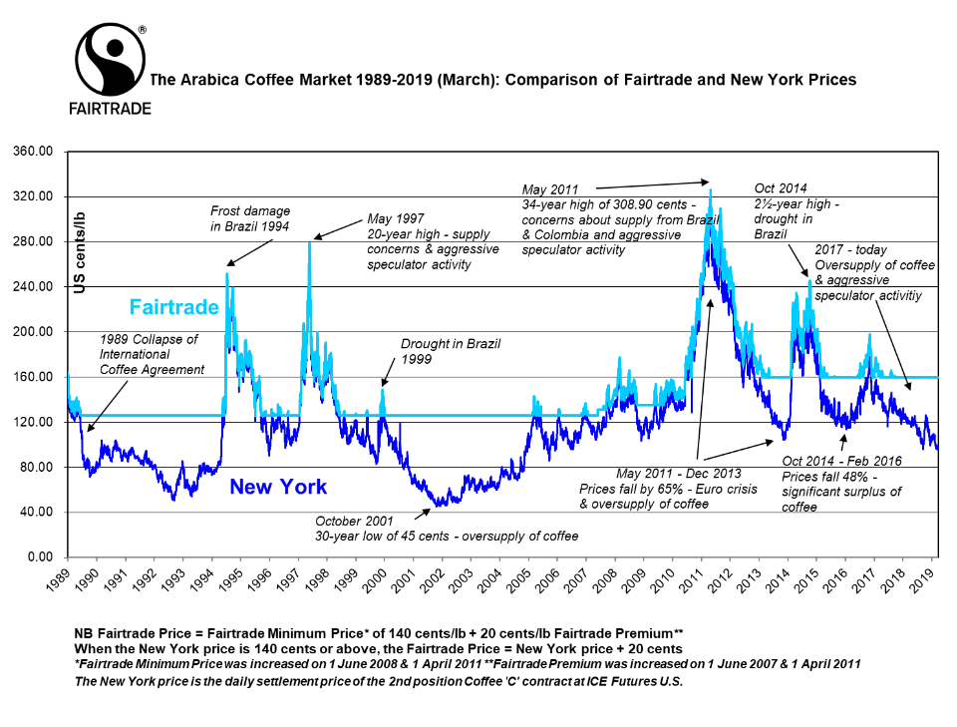

Better terms of trade are built into the Fairtrade Standards.
Price is just one tool used to support farmers in volatile markets. Based on our experience, companies and traders need to adopt policies like sharing of sourcing plans, applying reasonable payment terms, and facilitating access to pre-harvest financing. The Fairtrade Trader Standard requires just these kinds of things to build long-term, mutually-beneficial relations between producers and buyers, that allow producers to plan for the future and make strategic investments.

Fairtrade supports women coffee growers to become leaders and entrepreneurs.
The Fairtrade Standards require women to have equal opportunities within their cooperatives.
Take Ketra, a Ugandan coffee farmer and an accountant for her cooperative, Ankole Coffee Producers Cooperative Union. “Fairtrade has empowered women to take up big roles in leadership and at managerial levels… I’m an accountant and I’m a farmer at the same time, so it has empowered me. Fairtrade has helped us to grow, to help our farmers grow, to help our children go to school. It has changed our lives.”

Ankole is also one of three cooperatives that have recently launched the first Fairtrade robusta coffee brand owned by producers, Butonde Coffee.

Climate change affects coffee – and Fairtrade supports farmers to adapt.
Without strong climate action, your morning cup of coffee may become a distant memory. Research shows that the areas suitable for growing coffee could halve in a few decades. By 2080 wild coffee could even be extinct.

The Fairtrade Premium allows cooperatives to invest in climate adaption, for example by planting drought- or disease-resistant bushes. Fairtrade also works with commercial partners and donors to tackle climate change - for instance, a three-year project with Fairtrade Finland has supported almost 5,000 Honduran Fairtrade coffee farmers to become more resilient to climate change and to recover from a devastating epidemic of coffee rust disease (known as ‘la Roya’).

The future of coffee depends on farmers being able to earn a decent living.
Fairtrade wants to ensure farmers don’t just survive but thrive.

Our living income strategy sets out what a farmer needs to be paid to afford the basics including nutritious food, clothing, housing and education for their children. A fair price is key, but there’s also productivity, quality and cost-efficient farming. At least five cents per pound of the Fairtrade Premium goes to improving productivity and quality.

Paul Katzeff, CEO of Thanksgiving Coffee and one of the founders of Specialty Coffee Association of America, agrees that a decent income for coffee farmers is essential. “We need to keep our focus on what is needed to provide a true living income for this generation of farmers as well as the next. I believe that the Fairtrade movement is a way we can bring pricing more closely in line with the actual costs of production, improving the lives of farming families around the world.”

We continue to push for change, and to drive benefits for more than 760,000 Fairtrade coffee farmers. As part of that, we’ve just kicked off a review of our coffee standard, which will help smallholder farmers get a fairer slice of the $200 billion global market.
In the meantime, grab yourself another cup of Fairtrade coffee and know you’re doing your part to support coffee farmers around the world.

